UNIVERSITY OF MUMBAI

PROJECT REPORT ON

**MARKETING OF SKIN CARE PRODUCTS IN INDIA**

In the partial fulfilment for

Bachelors of Management Studies (BMS)

SUBMITTED BY

Pranav Parab

TYBMS Sem V (2013-14)

UNDER THE GUIDANCE OF

Prof. Ms. Shruti Rajeev

Vishwehwar Education Society’s

Western College of Commerce And Business Management

Sanpada, Navi Mumbai 400705.

Vishweshwar Education Society’s

WESTERN COLLEGE OF COMMERCE & BUSINESS MANAGEMENT

Plot No. 2, Sector – 9, Sanpada, Navi Mumbai - 400705

**CERTIFICATE**

This is to certify that

Mr./Ms. ______________________________________________ of

TY BMS has undertaken and completed the project work titled

_________________________________________ during the

academic year ____________________ under the guidance of

Mr./Ms. ___________________ submitted on ____________ to

this college in fulfillment of the curriculum of **Bachelor of Management**

**Studies, University of Mumbai.**

Project Guide BMS HoD Principal External Examiner

Date:

**DECLARATION**

I, _______________________________________student of TYBMS,

Seat No *Vishweshwar Education Society’s* WESTERN COLLEGE OF COMMERCE & BUSINESS MANAGEMENT hereby declare that I have completed the project report on _______________________________________ in the academic year _____________. The information submitted by me is true & original to the best of my knowledge.

# INDEX

**1- Introduction**

**2-Methodology**

**3-About Marketing**

**4-Large players dealing in Skin Care products in India**

**5-Marketing Mix**

**6-STP in Skin Care products**

**7-Ayurveda**

**8-Marketing strategies of companies manufacturing Skin Care products**

**9-Consumer Survey**

**10- Recommendations**

**11- Questionnaire**

**13-Conclusion**

**14-Bibliography**

# 

# INTRODUCTION

The skin is the body's protective barrier against the environment. We often take our skin for granted. Most people fail to realize that the skin needs daily care just like brushing one's teeth. If the skin is not taken care of properly it can become dry, flaky, cracked and inflamed. This can predispose the skin to infection from wart viruses and bacteria. A daily skin care regimen should start as early as infancy and continue throughout one's life.

Natural Skin care is the care of the skin using naturally derived ingredients combined with naturally occurring carrier agents, preservatives. The classic definition of natural skin care is based on using botanically sourced ingredients currently existing in or formed by nature, without the use of synthetic chemicals, and manufactured in such a way to preserve the integrity of ingredients.

Everyone has natural oil covering their skin. This oil, named sebum, is made by glands in the skin. When the oil is removed by frequent use of drying agents, such as soap, the skin becomes dry which can lead to cracking and flaking. Once cracking occurs the skin is susceptible to inflammation and itching. Everyday factors that may cause drying of the skin include harsh soaps, long hot baths or showers, and frequent bathing or showering. Most people overdo skin cleaning.

**Basic steps of Skin Care Needs:**

Before we start with the proper daily basic step skincare routine, you'll need to know your skin type. How you care for your skin is utterly dependent on the type of skin you have: oily, normal/combination, dry, sensitive or sun- damaged.

**Step 1: Cleansing:**

Cleansing is a critical daily skin care step. Not cleansing properly can also strip the skin of natural oils that are important to keeping it soft and healthy. Wash face using a gentle cleanser, with fingers, moving in a circular motion. Limit showers and baths to 15 minutes and use warm, not hot, water and a foaming cleanser. Depending on whether your skin is [normal to oily](http://www.tomigion.com/phpshop/index.php?page=shop/flypage&product_id=202&category_id=33c4c7bfe01d42684c2dd4f7f7fb67c6) or [normal to dry](http://www.tomigion.com/phpshop/index.php?page=shop/flypage&product_id=203&category_id=33c4c7bfe01d42684c2dd4f7f7fb67c6), you should use cleansers and products that are formulated for your specific skin type.

**Step 2: Exfoliate:**

Dead cells prevent moisture from being absorbed into the skin. Also exfoliation may help protect skin from skin cancer by eliminating abnormal cells before they become dangerous. A [granular scrub](http://www.tomigion.com/phpshop/index.php?page=shop/flypage&product_id=73&category_id=33c4c7bfe01d42684c2dd4f7f7fb67c6) or [moisturizing cleanser](http://www.tomigion.com/phpshop/index.php?page=shop/flypage&product_id=46&category_id=33c4c7bfe01d42684c2dd4f7f7fb67c6)  helps to slough off dead cells from the skin surface. If your skin is sensitive, use a synthetic puff or natural sponge. A callous remover is great to use on extra-thickened dry skin areas. It helps to draw toxins from the skin and gently exfoliates.

**Step 4: Toning:**

Toners tighten the pores and restore pH balance to the skin while cleaning it of excess cleanser and makeup. Natural additives such as [Vitamin C](http://www.tomigion.com/phpshop/index.php?page=shop/flypage&product_id=42&category_id=33c4c7bfe01d42684c2dd4f7f7fb67c6) (which is an anti-oxidant and helps formulate collagen) and Almond oil extract calm and heal skin. It’s a healthy, relaxing treat for your skin.

**Step 3: Moisturize:**

After [cleansing](http://www.tomigion.com/phpshop/index.php?page=shop/flypage&product_id=110&category_id=4aaf6d4bb704034731e9b10e698a8018), exfoliating or [toning](http://www.tomigion.com/phpshop/index.php?page=shop/flypage&product_id=43&category_id=33c4c7bfe01d42684c2dd4f7f7fb67c6), pat dry with a towel, don’t rub (so that you leave your skin slightly damp) and apply moisturizer. Applying moisturizer to slightly damp skin protects your skin to lock in moisture and provide a healthy supply of daily essential nutrients. Using skin nourishing cream moisturizers not only help to protect and soften skin but also add beneficial natural emollients while they moisturize to keep skin younger looking.

**Current Trends in Skin Care:**

Top beauty trends to watch over the years in skin care are as follows:

1. Focus on Color.

2. Enjoying a Salon Experience at Home.

3. Avoiding the Plastic Surgeon.

4. Even Men Moisturize.

5. Targeting Teens.

6. Caring Cosmetics.

7. Wipes & Swabs (wash or scrub).

8. You can take it With You.

9. Closer Targeting.

10. Well-Being.

**METHODOLOGY**

1. Formulating the Research Problem

2. Research Design

3. Determining sources of Data

4. Designing Data

5. Determining Sampling Design and Sampling Size

6. Processing and analyzing the data

7. Preparing the research report.

1. **Formulating the research problem:**

At first I required to know the marketing strategies followed in the organizations. I required studying the latest developments happening to make the marketing strategies more effective. I was also required to understand whether organizations followed marketing strategies and accepted as a cost benefit activity. It took me 3 months to

prepare the entire project and present precise data.

1. **Research Design:**

Every project requires an action plan and method for conducting a study. My project is more prone to descriptive research as all my findings are based on both primary as well as secondary data.

1. **Sources of Data:**

After listing down the methods of study and the activities to be done to complete my project, I started with the implementation of the activities. My project is based on primary as well as secondary data. The first aspect that was to be carried out was to read the book

**A. Reading Books**

This was an important aspect of my project as it was necessary for me to get an insight of marketing and marketing strategies and different strategies that were generally followed by the company that manufacturing skin care products. The book that helped me was:

* Marketing Management

- Kevin Lane Keller

**B. Internet**

After knowing about the various marketing it was necessary for me to understand its implementation by the organizations. I discovered companies dealing in skin care products and visited their respective websites and various other related links to collect the information.

**C. Consumer Survey:**

I have also conducted a survey on various reactions of the consumers on the skin care product they are using.

1. **Designing Data Collection Forms:**

I visited the consumers residing in Mumbai and interviewed them which included only the females between the age-group of 15-45, regarding the skin care products used by them. I had also prepared a questionnaire of 12 relevant questions. The final questionnaire is annexed in the schedule of annexure.

1. **Determining Sampling Design and Sampling Size:**

I decided to take a sample survey and interviewed a sample size of 50 which included only females.

1. **Processing and Analyzing the Data:**

After the very arduous task of collecting the data, now I was required to analyze the data from every aspect. It was essential to present the relevant data in the correct form. Hence, usage of pie charts and bar graphs is done in the project to make it easier and appropriate to understand.

1. **Preparing the Research Report:**

After collecting and analyzing all the facts and aspects, final report was prepared with all the key points taken into consideration.

**WHAT IS MARKETING STRATEGY?**

The marketing strategy is shaped by your overall business goals. It includes a definition of your business, a description of your products or services, a profile of your target users or clients, and defines your company's role in relationship to the competition.

The marketing strategy is essentially a document that you use to judge the appropriateness and effectiveness of your specific marketing plans.

To put it another way, your marketing strategy is a summary of your company's products and position in relation to the competition; your sales and marketing plans are the specific actions you're going to undertake to achieve the goals of your marketing strategy.

**ROLE OF MARKETING STRATEGY**

A good marketing strategy provides specific goals and can include:

* a description of the key target buyer/end user
* competitive market segments the company will compete in
* distribution channels
* the unique positioning of the company and its products versus the competition
* the reasons why it is unique or compelling to buyers
* price strategy versus competition
* marketing spending strategy with advertising and promotion
* possible research and development
* market research expenditure strategies.

An overall company marketing strategy should also:

* define the business
* position the business as a leader, challenger, follower, or niche player in the category
* define the brand or business personality or image that is desired in the minds of buyers and end users
* define life cycle influences, if applicable

**U**se the following checklist to help create your own marketing strategy.

**Marketing strategy checklist Strategy**

* Identify your target buyers/end users
* Establish the marketing category (e.g., fast food purveyor, high-end audio equipment sales, etc.)
* Determine whether your company will be a market category leader, follower, challenger, or niche player
* Describe the unique characteristics of your products or services that distinguish them from the competition.
* Define whether your pricing will be above, below, or at parity with your competitors and establish whether you will lead, follow, or ignore changes in competitors' pricing
* Identify the distribution channels through which your products/services will be made available to the target market/end users
* Describe how advertising and promotions will convey the unique characteristics of your products or services
* Describe any research and development activities or market research plans that are unique to your business
* Describe the image or personality of your company and its products or services

**LARGE PLAYERS DEALING IN SKIN CARE PRODUCTS IN INDIA**

The big names in the skin care industry are as follows:

1. **Himalaya**

* Himalaya Face pack
* Himalaya Face toner
* Himalaya Facial cleansers
* Himalaya Fairness
* Himalaya Moisturizers
* Himalaya Soaps
* Himalaya Face washes

1. **Dabur**

* Gulabari rose water
* Gulabari face freshner
* Gulabari rose cream
* Gulabari rose lotion
* Vatika Fairness face cream
* Vatika saffron glow soap with sandal

1. **CavinKare**

* Fairever Cream
* Nyle cold cream and lotion
* Spinz talcum powder
* Spinz deodorants

1. **Hindustan Unilever**

* Soaps like Lux, Lifebuoy, Liril, Hamam, Dove, Breeze, etc.
* Vaseline
* Pond’s
* Fair and Lovely
* Aviance

1. **Johnson & Johnson**

* Neutrogena
* Johnson’s
* Avenno
* Ambi skin care
* Clean and Clear

Some of the skin care products

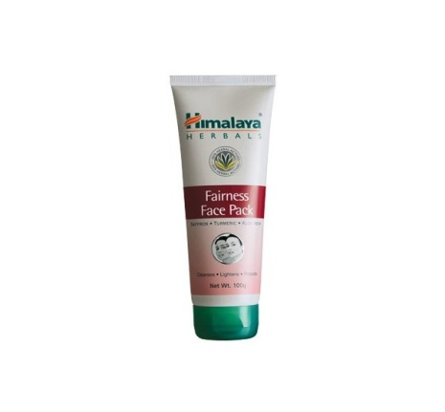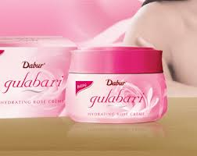

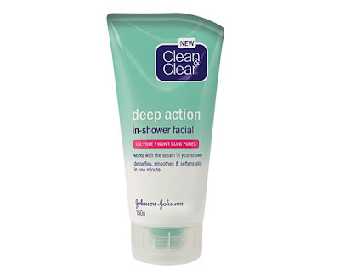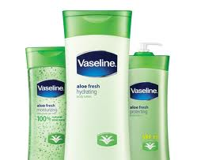

\

**MARKETING STRATEGIES OF SKIN CARE PRODUCTS**

**4 P’s of skin care products:**

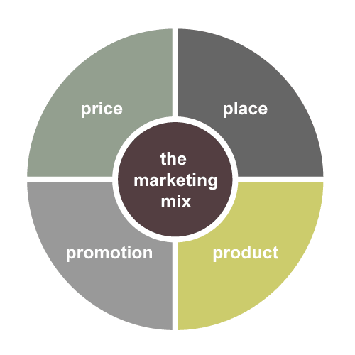

**The Marketing mix is a business tool used in marketing professionals. The Marketing mix is often crucial when determining a product or brands offer**

**is often synonymous**

**The four Ps**

**1-Product**

**2-Price**

**3-Place**

**4-Promotion**

**Product Strategy:**

Anything offered in the market to satisfy the consumer needs is known as product. Products are not just goods in tangible form but also it consists of services, ideas, experiences, events, etc.

There are various types of skin care products and their services offered in the market. It differs in various ways like size, shape, price, color, features, uses, etc. These varieties are thus classified in certain groups:

* Durability and Tangibility
* Consumer goods classification

Skin care products are type of consumer goods which are based on the shopping habits of different types of customers having different perception, likes and dislikes, tastes and preferences, and after all he/she has the desire to buy a product with the backbone of ability to buy it.

Skin care products are categorized into herbal and non- herbal skin care products which are further categorized in the form of creams, lotions, talcum powder, soaps, deodorants, face packs, etc.

Product level:

* Basic product:

Actualizing a core benefit in a product is a basic product. This is what will be seen in selecting skin care products. The main feature of skin care products is the ingredients and fragrance or flavour which it contains.

* Differentiation:
  1. Form: Many products can be differentiated in form-the size, shape, or physical structure of a product. The skin care products also consider many possible forms like size shape color or action time.
  2. Features: Most products can be offered with varying features that supplement its basic function. Each company selling skin care products must decide whether to offer feature customization at a higher cost or a few standard packages at a lower cost.
  3. Performance Quality: Performance Quality is the level at which the product’s primary characteristics operate. The manufacturer of skin care products must design a performance level appropriate to the target market and competitors’ performance level. A company must also manage performance quality through time. Continuously improving the product can produce the high returns and market share.
  4. Conformance Quality: Buyers expect that the skin care products whether herbal or non-herbal must have a high conformance quality, which is the degree to which all the produced unite are identical and meet the promised specifications. Suppose a fairness cream is designed to improve the skin quality within a month. If very fairness cream does this, the product is said to have a high conformance quality. The problem with low conformance quality is that the product will disappoint buyers.
  5. Durability: It is a measure of the product’s expected operating life under natural or stressful conditions, is a valued attribute for certain products. In case of skin care products, they have a short operating life. Very skin care product is mentioned with an expiry date. After that date product should not be used further as it may cause damage to the skin.
  6. Reliability: Buyers normally pay a premium for more reliable products. Reliability is a measure of the probability that a product will not malfunction or fail within a specified time period. Both herbal and non-herbal skin care products usually don’t malfunction before the specified time period. They are reliable in nature.
  7. Repairability: It is a measure of the ease of fixing the product when it malfunctions or fails. Ideal repairability would exist if users could fix the product themselves with little cost in money or time. But the skin care products are not a subject to repairability. If a skin care product malfunctions or fails, the product has to be exchanged or the buyer has to buy a new one.
  8. Style: Style describes the product’s look and feel of the buyer. Style has the advantage of creating distinctiveness that is difficult to copy. The companies manufacturing skin care products adapt different styles of products to sell in the market.

**Design of a product:**

As competition intensifies, design offers a potent way to differentiate and position a company’s products and services.

Design is the factor that will often give a company its competitive edge. Design is the totality of features that affect how a product looks and functions in terms of customer requirements.

Design is particularly important in making and marketing retail services, apparel, packaged goods and durable equipment.

All the qualities discussed above are design parameters.

The designer of skin care products has to figure out how much to invest in form, feature development, performance, conformance, durability, reliability, repairability and style.

To the company, a well-designed product is one that is easy to manufacture and distribute.

To the customer, a well-designed product is one that is pleasant to look at and easy to open, install, use, repair, and dispose of

. The designer of the skin care products has to take all these factors into account.

**Price Strategy:**

In general terms, price is a component of an exchange or transaction that takes place between two parties and refers to what must be given by one party (i.e. buyer) in order to obtain something offered by another party (i.e. seller). The pricing decision is a critical one for most of the marketers.

Companies manufacturing skin care products do their pricing in different ways. In small companies, prices are often set by the boss. In large companies, pricing is handled by division and product-line managers. Consumers are assumed to be the “price takers” and accept prices at “face value” or as given. Marketers of skin care products recognize that consumers often actively process price information, interpreting prices in terms of their knowledge from prior purchasing experience, formal communications (advertising, sales calls, and brochures), informal communications (friends, colleagues, or family members), and point-of-purchase or online resources.

Purchase decisions of consumers for skin care products are based on their perception and what they consider to be the current actual price.

A firm must set the price for the first time when it develops a new skin care product, when it introduces its regular skin care product into a new distribution channel or geographical area, and when it enters bids on new contract work. The firm must decide where to position its product on quality and price.

The firm which manufactures skin care products has to consider many factors in setting its pricing policy:

1. Selecting the pricing objective:

The Company first decides where it wants to position its market offering. A company can pursue any of 5 major objectives through pricing:

* + Survival: Here the company sets such a price which covers all variable and some fixed costs to stay in the business. It is a short-run objective.
  + Maximum Current Profit: Many companies manufacturing skin care products try to set a price that will maximize current profits.
  + Maximum Market Share: Some companies want to maximize their market share. They set the lowest price and achieve higher sales volume.
  + Maximum Market Skimming: Companies unveiling a new technology favor setting high prices to maximize market skimming. Here, the prices start high but they are slowly lowered over time.
  + Product-Quality Leadership: Many brands have been able to position themselves as quality leaders with an intensely loyal customer base.

1. Determining Demand:

The demand of a product is inversely related to its price. The higher the price, the lower the demand and vice-versa.

* Price Sensitivity: Customers are most price sensitive to products that cost a lot or are bought frequently. They are less sensitive to low –cost items or items they buy infrequently. In case of skin care products, customers are price sensitive as some skin care products cost a lot and they are the consumer goods which are bought frequently by them.
* Estimating Demand Curves: Most companies make some attempt to measure their demand curves using several different methods like statistical analysis, price experiments and surveys.
* Price Elasticity of Demand: Marketers need to know how responsive, or elastic, demand would be to a change in price. If demand hardly changes with a small change in price, we say the demand is inelastic. If demand changes considerably, demand is elastic. The demand for skin care products is inelastic.

1. Estimating Costs:

The company wants to charge a price that covers its cost of producing, distributing, and selling the product, including a fair return fir its effort and risk.

1. Analyzing Competitors’ Costs, Prices and Offers:

The firm manufacturing skin care products must take competitors’ costs, prices, and possible price reactions into account. According to that the firm can fix the prices for its product.

1. Selecting the Pricing Method:

Companies can now select a pricing method through which their final price for a product may occur. The manufacturers of skin care products can go with any of the following pricing methods:

* Perceived-value Pricing
* Value Pricing
* Going-rate Pricing

**Distribution (Place) Strategy:**

The place factor of 4P’s mainly consisting of the distribution channel involved in the marketing process. It’s the way in which the product is made available easily and feasibly to the end customers with the involvement of various intermediaries.

A value network is a system of partnerships and alliances that a firm creates to source, augment and deliver its offerings. Most producers of skin care products do not sell their goods directly to the final users; between them stands a set of intermediaries performing a variety of functions. These intermediaries constitute a marketing channel (distribution channel).

Some intermediaries in distributing skin care products are wholesalers, retailers, transportation companies, warehouses, etc. Marketing Channels are sets of interdependent organizations involved in the process of making a product or service available for the use of consumption.

# Why marketing channels for skin care products?

* Many producers manufacturing skin care products lack financial resources to carry out direct marketing.
* In some cases direct marketing is simple not feasible.
* Producers who do establish their own channels can often earn a greater return by increasing their investment in their main business.

Intermediaries normally achieve superior efficiency in making goods widely available and accessible to the target markets. Through their contacts, experience, specialization, and scale of operation, intermediaries usually offer the firm more than it can achieve on its own.

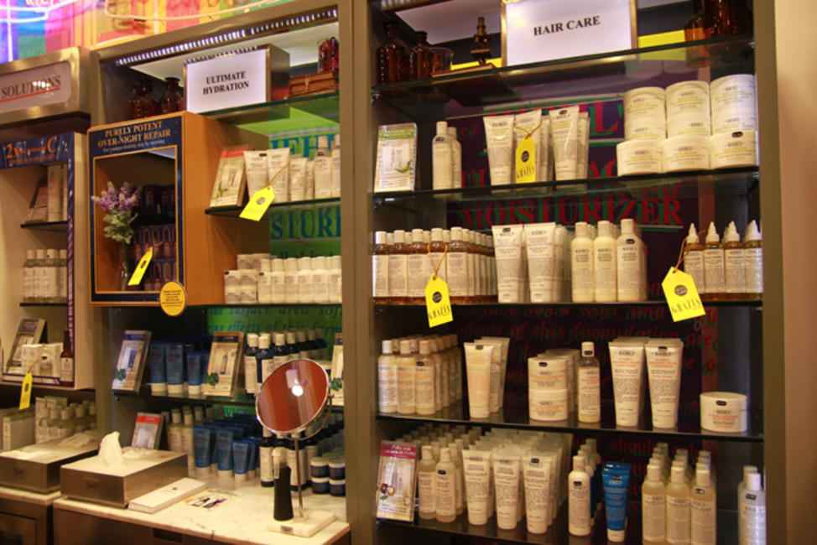

The key functions performed by the members of marketing channel for distributing skin care products are as follows:

* They gather information about potential and current customers, competitors, and other actors and forces in the marketing environment.
* They develop and disseminate persuasive communications to stimulate purchasing.
* They reach agreements on price and other terms so that transfer of ownership or possession can be affected.
* They place orders with manufacturers.
* They acquire the funds to finance inventories at different levels in the marketing channel.
* They assume risks connected with carrying out channel work.
* They provide for the successive storage and movement of physical products.
* They provide for buyers’ payment of their bills through banks and other financial resources.
* They oversee actual transfer of ownership from one organization or person to another.

In consumer markets, there are two intermediaries. They are typically wholesalers and retailers. It is also known as two-level channel. Since the skin care products are consumer goods, they follow the two-level marketing channels which consists of wholesalers and retailers as intermediaries.

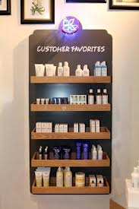

**Promotion Strategy:**

A promotion is the means by which firms attempt to inform, persuade and remind consumers-directly or indirectly- about the products and brands that they sell. Through promotions, companies manufacturing skin care products can show and tell the consumers how and why a skin product is used, by what kind of a person it should be used, and where and when it should be used. Consumer can also learn about who makes the skin care product and what the company and brand stand for.

It can also contribute to brand equity by establishing the brand in memory and crafting a brand image.

Companies manufacturing skin care products can do their promotions in the following ways:

# Advertising –

**Any** paid form of non personal presentation and promotion of ideas, goods, or services by an identified sponsor.

Advertising is a powerful factor in convinicing people to purchase products.

A well designed ad promotes the benefits that a targeted audience is looking for in the products or services it uses.

When advertising skin care products and other beauty items companies illustrate the results on real people showing others that they too can look just as greater after use this is enough to make anyone want to apen the wallet and shell out some hard earned cash.

* Print and broadcast ads
* Packaging-outer
* Brochures and booklets
* Posters and leaflets
* Billboards
* Display signs
* Point-of-purchase display
* Audiovisual material
* Symbols and logos
* Videotapes

Advertising in Skin Care Sector:

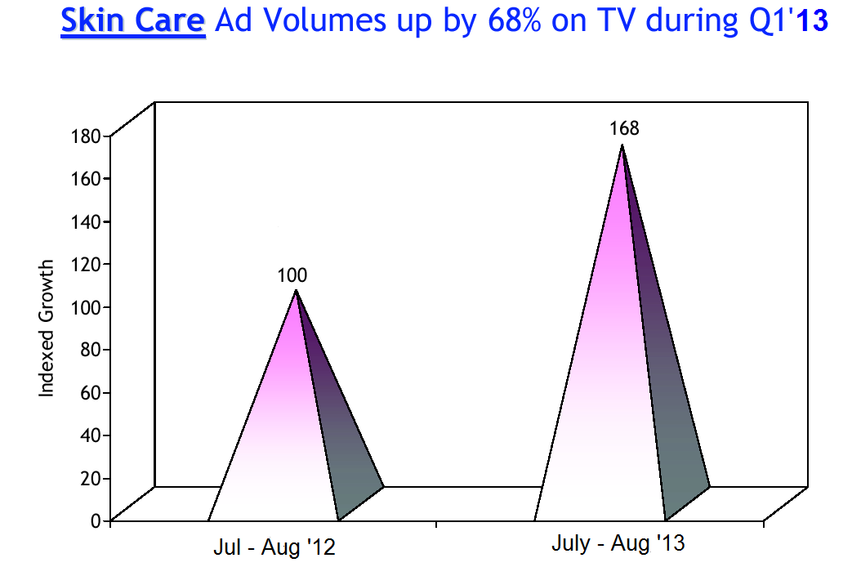

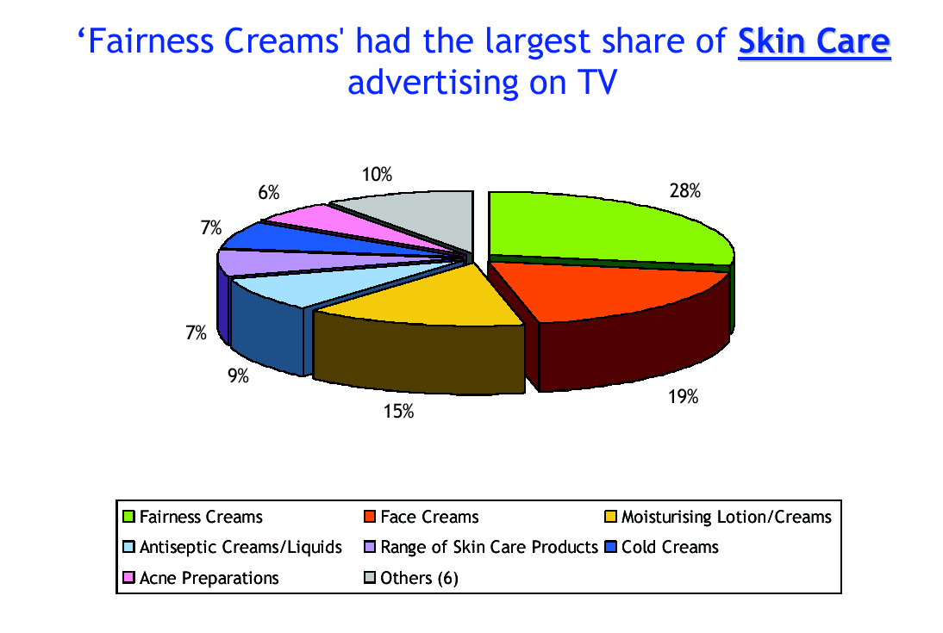

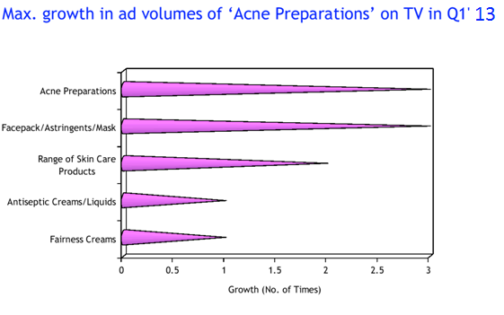

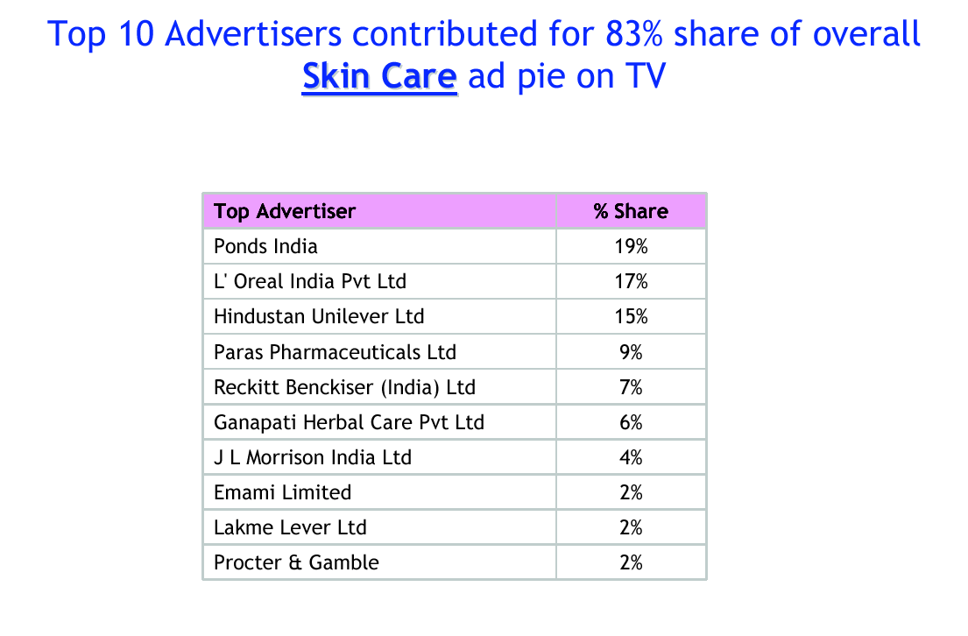

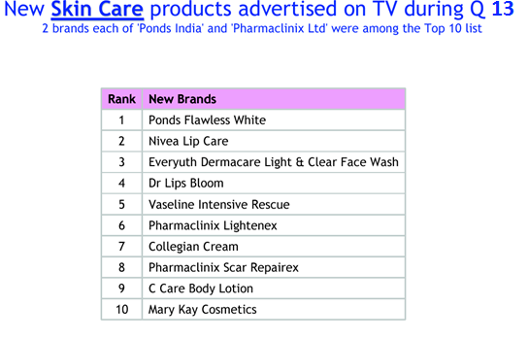

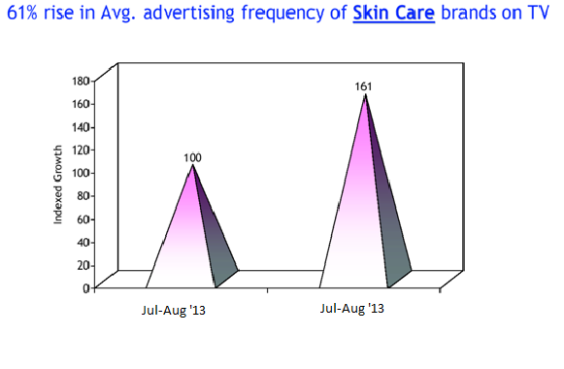

# Sales promotions –

* Sampling
* Exhibits
* Demonstrations
* Coupons
* Rebates
* Tie-ins
* Fairs and trade shows
* Contests, game, sweepstakes, lotteries
* Premiums and gifts

1. **Public relations and publicity** – A variety of programs designed to promote or protect a company’s image or its individual product.

* Press kits
* Speeches
* Seminars
* Annual reports
* Sponsorships
* Events
* Identity media
* Publications

**Personal Selling** –

Face-to-face interactions with one or more prospective purchases for the purpose ofmaking presentations, answering questions, and procuring orders.

* Sales presentations
* Sales meetings
* Incentive programs
* Samples
* Fairs and trade shows

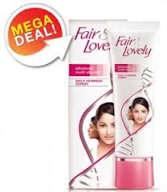

# Direct marketing –

Use of mails, telephone, fax, e-mail, or Internet to communicate directly with or solicit response or dialogue from specific customers and prospects.

* Catalogs
* Mailings
* Telemarketing
* Electronic shopping
* TV shopping
* Fax mail
* E – mail
* Voice mail

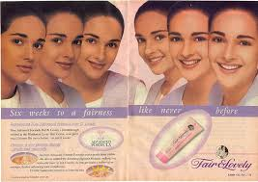 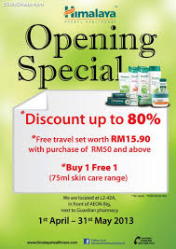

Advertising of skin care products has become some what of an art form.

It has also become big business with companies playing top dollar to hire marketing geniuses or retain the best advertising or consulting firms.

Advertisers must stay one step ahead of consumers and their buying habits to harness the constantly changing behavior and trends for their benefit.

**STP of Skin Care Products:**

**Segmentation:**

The division of market into different homogeneous groups of customers is known as market segmentation. It helps to satisfy the customer’s needs easily.

A market segment should be:

* Measurable
* Assessable by communication and distribution channels
* Different in its response to a marketing mix
* Durable(not changing to quickly)
* Substantial enough to be profitable

One can identify 4 primary bases on which to segment a consumer market:

* Geographic
* Demographic
* Psychographic
* Behavioral

Companies dealing in skin care products divide the market into different segment according to the products offered by them. They can be divided on the basis of geographic and demographic segmentation.

1) Geographic Segmentation:

It calls for dividing the market into different geographical units such nations, states, regions, counties, cities, or neighborhood.

The companies manufacturing skin care products can operate in one or few areas, or operate in all but pay attention to all local variations.

Climate of one region or state differs from another region or state in India. The skin types of individuals (dry, oily, etc.) in different regions also differ due to their respective climatic conditions.

Hence, these individuals buy only that product which suits their skin or according to the climate or region in which they stay.

For example, in hot regions people prefer to buy sun screen lotions and creams whereas in cold regions people prefer to buy cold creams, moisturizers, lotions, etc

2) Demographic Segmentation:

Here, the market is divided into groups on the basis of variables such as age, family size, family life cycle, gender, income, occupation, education, religion, race, social class, etc.

The companies manufacturing skin care products usually go with demographic variables to segment the market because it is easier to measure. They can use age, gender, income as their demographic variables to segment the market.

* Age: Usually the companies manufacturing skin care products segment the market into all types of age groups from kids to teenagers and from adults to older consumers because all the age group’s consumers care for their skin and buy the skin acre product as per their needs and requirements.
* Income: Income segmentation is a long standing practice in skin care products and cosmetics industry. Some skin care products are prices low while some are very expensive. So, if the person is buying the skin care product he/she has to think about the price and their income before buying the product.
* Gender: Male and Female both of them use the skin care products but female consumers care more for their skin than the male consumers. The skin type of male consumers differs from that of female consumers. According to that, the companies should manufacture the skin care products and sell them to a particular segment group.

# Targeting:

Once the firm has identified its market segment opportunities, it has to decide how many and which ones to target.

The companies manufacturing skin acre products usually target the female consumers between the ages of 15-45.

They are the one’s who go to buy the skin acre products from various retail outlets. They are the one’s who consumes or uses the skin care product more as compared to the male consumers.

Females care more for their skin because they are obsessed to look beautiful and stunning. Usually companies do not target infants or kids but there are companies like Johnson & Johnson who do target the kids and infants because they manufacture those skin care products which suits their skin.

# Positioning:

Positioning is the act of designing the company’s offering and image to occupy a distinctive place in the mind of the target market. If a company does an excellent job of positioning, then it can work out the rest of its marketing planning and differentiation from its positioning strategy.

The goal of companies manufacturing skin care products is to locate their brand in the minds of the consumers to maximize the potential benefit to the firm. A good brand positioning of skin care product helps to guide marketing strategy by classifying the brand’s essence, what goals it helps the consumers to achieve, and how it does in a unique way. Some companies price their brand at a low value to position their brand in the minds of the consumers, some companies provide good quality products, while some of them provide both. If a consumer wants a product at a low price, he/she positions that brand which is available at a low price. If a consumer wants a product with good quality, he/she positions that brand which provides good quality.

For example, companies like HUL, Dabur, etc who manufactures skin acre products have a good positioning in the market.

# WHAT IS AYURVEDA?

Ayurveda is a Sanskrit term, made up of the words "*ayus*" and "*veda*." "*Ayus*" means life and "*Veda*" means knowledge or science. The term "*ayurveda*" thus means 'the knowledge of life' or 'the science of life'. According to the ancient Ayurvedic scholar Charaka, "ayu" comprises the mind, body, senses and the soul.

Ayurveda literally means "science of life and longevity." and is considered to be the traditional system of medicine of India. Ayurveda is a science in the sense that it is a complete system. It is a qualitative, holistic science of health and longevity, a philosophy and system of healing the whole person, body and mind.

The origin of this system goes back to a far past, in which philosophy and medicine were not separated. Therefore, philosophical views have strongly influenced the Ayurvedic way of thinking.

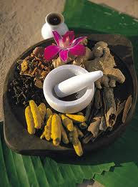

**AYURVEDIC/HERBAL SKIN CARE PRODUCTS**

* **Herbal medications** are very effective for sensitive skin, as the products are free from the insensitive chemicals that can lead to **skin tribulations**.
* Generally the **herbal products** possess natural components which are healthier for sensitive skin and skin irritations do not occur.
* Amongst **herbal products** almond or **jojoba oil** can be used to clean the face.
* A facial pack can be prepared by mixing grapefruit with oatmeal to apply on the face as it will trigger of irritation.
* Comfrey steeped in **water act** as the good toner for the sensitive skin amongst **herbal products**.
* Green tea possesses the properties of anti-inflammatory feature which prevent reactions of the **sensitive skin**.
* A **face mask** made of cucumber and yoghurt can also used for **sensitive skin types**.
* **Aloe Vera** acting as the smoothing of the **skin** that is red, aggravated and blemished can be applied directly on the skin.

**HISTORY OF AYURVEDIC/HERBAL SKIN CARE PRODUCTS**

There are many Herbs available which can take care of your skin like a mother's hand over her baby.

Carefully created and prepared herbal [skin care products](http://www.online-vitamins-guide.com/herbs/herbal-skin-care.htm) calms dry areas and balances the skin composition. The knowledge of nature can correct the damage generally done daily with our modern lifestyle. Healthy diet is the key to all these lifestyle problems. With organic oils like olive, cocoa butter and more, we believe you'll enjoy using these simple handmade pleasures every day.

Herbs and the plant extracts are good for cleansing and healing our sun damaged skin. Since old times, women have turned to the hands of nature to help increase their own beauty. The Romans used beauty packs of eggs and honey (amongst others), and Egyptians are well-known for their use of oils and perfumes.

Pampering our skin is something we should learn to do for our health and well being. Flowers and other plant materials used are hand-gathered at the peak of their natural seasonal vitality for that extra look and feel.

Ancient Sages who founded Ayurveda about 5000 years back discovered that plants and plant extracts had a startling effect on skin and hair. Water, Light, Air, Heat of the Sun, Minerals and Plant have immense medicinal and therapeutic value which play an important part in leading a healthy, fulfilled and aware life.

Herbal nutrients are required to support healthy metabolism and maintain functions of human body. Known vitamins are just one example of our dependency on herbal supplements. Herbal medicines were used for thousand years to fight diseases and improve body functions. Herbal nutrients have been shown to help heal many maladies, improve general health and specific pathological conditions. Herbs can help fight disease and premature aging, maintain sustainable and enjoyable lifestyle.

**NATURAL SKIN CARE AUTHORITY**

The purpose of this section is to help you understand the rating parameters used to grade the skin care products. This will help you separate fact from fiction regarding the use of skin care toxins and natural ingredients. The grading components are natural parameters, toxic parameters, and the sources used.  
  
The products reviewed cover a wide range of skin care products. It includes products marketed as natural, certified organic as well mainstream commercial brands. Each product is reviewed according to the ingredient list- required by law.

|  |  |  |
| --- | --- | --- |
| [Natural Parameters](http://www.natural-skincare-authority.com/skin-care-toxins.html#NaturalParameter#NaturalParameter) | [Toxic Parameters](http://www.natural-skincare-authority.com/skin-care-toxins.html#ToxicParameter#ToxicParameter) | [Sources Used](http://www.natural-skincare-authority.com/skin-care-toxins.html#SourcesUsed#SourcesUsed) |

**Step By Step Rating Process:**  
Each product has been put through 20 different natural parameters. The following is the process:

1) The ingredient list for each skin care product is sourced from official company websites. This list is then cross referenced with the major skin care portals like Drugstore.com and SkinStore.com  
  
2) A natural profile is built by running the ingredient list through 8 natural parameters. Each natural parameter is assigned a different weighting according to its importance. A natural score is then assigned to the product.

3) A toxic profile is built by putting the product through the 12 toxic parameters. Skin care toxins are also assigned a different weighting according to their level of toxicity. A toxic score is assigned to the product.

4) A final score is given to each product. This is calculated by using a default score of 5.0. The natural score out of 5.0 is added and a toxic score out of 5.0 is subtracted. The final score is a balanced rating out of 10.0

**Natural Parameters:**  
1) Certified Organic - There are several independent certifying bodies in many different nations.

2) 100% Natural Ingredients - This is a necessary parameter because some products may contain all natural ingredients without actually being certified organic.

3) No Synthetic Chemicals - This important parameter establishes whether the product contains any chemicals. These substances are not derived from natural sources.

4) Cruelty Free - This determines whether any ingredient was tested on animals during the research and/or manufacture of the product. Using FDA data this is possible to determine accurately.

5) No Pesticides - This determines whether pesticides were used in the production of plant source ingredients. A product being certified organic is the only reliable way to rule out the use of pesticides.

6) No Genetically Modified Organisms (GMO) - This parameter determines whether any plant sources have been corrupted with GMO. A product being certified organic is the only reliable way to rule out the use of GMO.

7) Cold Formulated - This is a manufacturing process that ensures natural ingredients are kept in their original fresh state by allowing no heat in during production.

8) Charitable Donations - By reviewing the official company website I am able to determine whether the company gives back to the community

**Toxic Parameters**-

1) Cancer: Proven Link - Through publicly available documents on chemicals it is possible to determine whether the product contains cancer causing chemicals - carcinogens. You may be shocked at the level of these skin care toxins in mainstream products.

2) Cancer - Possible Link - These chemicals make up a large portion of ingredients in many products. While no hard link has been established to cancer by the conservative research labs they are quite hazardous nonetheless.  
  
3) Reproductive Toxins - These skin care toxins have been deemed by the research community to have direct negative affects on the reproductive system of women and men. Importantly this includes pregnancy for mothers.  
  
4) Safety Violations - These are chemicals being used in skin care products that are in direct violation of government regulations. Hard to believe but true.  
  
5) Harmful Toxins - These skin care toxins are liberally used in many skin care products. In terms of toxicity they are generally a tier below the "cancer - possible link " parameter.  
  
6) Untested Chemicals - These chemicals have never been formally tested for safety for human use in skin care products.  
  
7) Penetration Enhancers - These skin care toxins infiltrate the skin membrane. This opens the door for many other chemicals to enter. This also is a direct violation of government regulations as cosmetics are not permitted to enter the bloodstream.   
  
8) Animal Tested - These chemicals have been tested on animals. A despicable practice has rightly drawn the ire of many consumers. One important point is to realize that many companies like the Body Shop outright lie about this issue by outsourcing these skin care toxins to third parties.

9) Dangerous Chemicals - These three parameters are specific chemicals assigned to individual product categories. They are the three most dangerous skin care toxins in that particular category.  
  
10) Misleading Advertising - This widespread practice determines whether a company uses deceptive advertising to trick customers into thinking their products are natural, organic or cruelty free.

**Sources Used:**  
**Natural Parameter Sources** - The following are some of the sources used in compiling the information for the natural score of each skin care product.  
  
[**ACO**](http://www.australianorganic.com.au/), Australian Certified Organic - An independent body based in Australia.  
  
[**BFA**](http://www.bfa.com.au/), Biological Farmer's Association - Parent body of the ACO.  
  
[**USDA**](http://www.ams.usda.gov/nop/indexIE.htm), United States Department of Agriculture - The US government body overseeing certified organic labeling.

[**IFOAM**](http://www.ifoam.org/), International Federation of Organic Agriculture Movements - International body overseeing organic agriculture.

[**JAS**](http://www.maff.go.jp/eindex.html), Japan Agricultural Standards - Japanese body enacted by law to oversee organic labeling.

**Toxic Parameter Sources** - These are the sources used to determine the toxic parameter score for each product.

[**EWG**](http://www.ewg.org/reports/skindeep/), Environmental Working Group - A research group based in the US.  
  
[**CIR**](http://www.cir-safety.org/), Cosmetic Ingredient Review - A self appointed body of cosmetic corporations overseeing the cosmetic industry.

**FDA**, Food & Drug Administration - US Government body overseeing the cosmetic industry.

[**Skin Care Toxins**](http://hazard.com/msds/) **Hazard MSDS** - Publishes material safety data sheets on all commercial chemicals.

[Scorecard.org](http://www.scorecard.org/) - Environmental Defense - Publishes pollution information.

[**HazMap**](http://hazmap.nlm.nih.gov/), Operational Exposure to Hazardous Agents - Information on hazardous chemicals and occupational diseases.

[**CDC**](http://www.cdc.gov/niosh/homepage.html), Center for Disease Control - Provides information to prevent work-related illnesses and injuries.

**MARKETING STRATEGIES OF COMPANIES MANUFACTURING SKIN CARE PRODUCTS**

1. **CavinKare Pvt. Ltd:**

Skin care products manufactured by CavinKare:

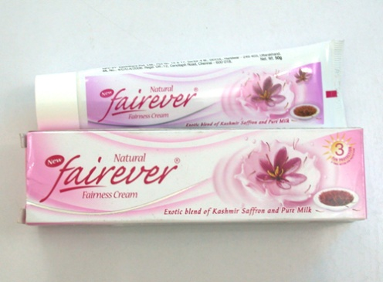 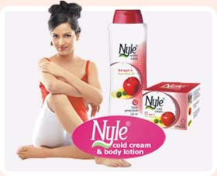

50 gm- Rs.59 25 gm- Rs.33

Pricing of the Herbal Products:

CavinKare has adopted value pricing. They win loyal customers by charging a fairly low price for a high quality offering. They even follow going-rate pricing where the pricing is matching the competitor’s pricing.

**Rural Marketing Strategy**:

* CavinKare associate with people of similar wavelength in thinking, who will definitely take care of quality first and foremost and besides, they have a strong system of quality monitoring.
* As part of their strategy, they lay down all the ground rules for the manufacturers in maintaining their standards.
* Outsourcing is one of the 3 cardinal rules of CavinKare’s corporate strategy.
* Direct media promotions have helped build knowledge of product categories and change long-entrenched living habits.
* By the help of effective communication they tried to understand the fears, aspirations, and hopes of the rural consumers.
* CavinKare believes that its core competencies are research and development, brand building and distribution management.
* It also has its own mobile beauty parlours to provide a complete brand experience.
* They are targeting girls’ colleges, market places and residential facilities.
* They are trying to enable their products to compete directly with market leaders such as HUL, Dabur, Himalaya, P & G, etc.
* To build a local and regional balance, they advertised in local prints and television, before taking the brands nationally. They advertised their products more often and hired well qualified professionals to compete with their competitors.
* Instead of using the conventional distribution route, they have created a ‘sachet’ sales force that sale only sachet packs to small retailers including cigarette and paan shops. Separate hawkers’ is being created that has moved from neighbourhood to neighbourhood. The hawker channel exists in all cities where they have a distribution network.
* The personal products division which includes skin care products is moving towards post offices. They are using such channels to expand product reach and gain accessibility.
* They also do retailer promotion. They give special gift if dealer sell more products in a particular season. They also give them discount on bulk purchasing.

**Urban Marketing Strategy**:

* The main strategy of Cavin Kare in urban areas is to strengthen the distribution and marketing of their skin care products-both herbal (fairever cream and nyle cold ceram and lotion) and non-herbal (spinz talcum powder and deodorants). The company made its brand available to the customer through out the country.
* Continuous concentration upon Research and Development is an added advantage to the company which has dedicated staffs. Their main job is to understand the needs of the target audience and to bring more innovative products.
* The Fairever woman in urban areas is today’s young and contemporary woman. She has strong values and believes in using a natural product that will help bring out her natural beauty from within. They are the company’s target.
* Nyle Cold cream and Winter lotion appeal to women of all age group and socio-economic class in urban area.

# 2-Dabour India-

Dabur India Limited is a leading Indian consumer goods company with interests in Hair Care, Oral Care, Health Care, Skin Care, Home Care and Foods.

From its humble beginnings in the bylanes of Calcutta way back in 1884 as an Ayurvedic medicines company,

Dabur India Ltd has come a long way today to become a leading consumer products manufacturer in India.

For the past 125 years, we have been dedicated to providing nature-based solutions for a healthy and holistic lifestyle.

2-Skin care products manufactured by Dabur:

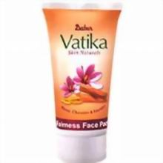 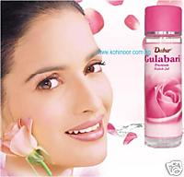

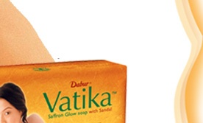 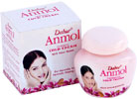

100 gm- Rs.13

**Pricing of the Herbal Products:**

They offer their ayurvedic products at the lowest price than others. After considering the shipping charges they come to a final price. Lower price and good quality helps them to build value for their product.

# Rural Marketing Strategy:

* 50% of Dabur Products available in rural market:

7% is contributed by the skin care products

For attracting more customers in the rural market, Dabur used the following promotional tools:

* 1. TV commercial
  2. Radio
  3. Newspaper
  4. POP display
  5. Wall painting
  6. Contest in melas or haats
  7. Video vans
  8. Sales promotion.

Dabur conducted various beauty contests in which the rural people have the interest.

Dabur is trying to capture market by launching products with a regional twist.

Dabur has also made continuous efforts towards technology absorption and innovation which have contributed towards preserving natural resources.

* They take in to account various distribution channels to distribute their products which are as follows:

1. Dealer
2. Wholesaler
3. Agents
4. Retailers
5. Kirana store

* They also promote contract farming.

# Urban Marketing Strategy:

* They continuously carry on research and development activities on ayurvedic and herbal products they manufacture and also n their other products.
* The market research division has segmented urban consumers on the basic of geographic variables, demographic variables and user status & lifestyle.
* It targets different segments of population of all categories of age groups.
* It has positioned itself as the 4th largest FMCG Company through its various products.
* It does their promotions through various advertising media like television, radio, internet, newspapers, magazines, hoardings, websites, etc in the urban areas.
* The company plans to open 50 stores by 2009.

# 3. Hindustan Unilever:

Hindustan Unilever is India’s Largest fast moving consumer goods company with a heritage of over 75 yrs in India and touches the lives of two out of three Indians.

With over 35 brands spanning 20 distinct categories such as soaps, detergents, shampoos, skin care, toothpastes, deodorants, cosmetics, tea, coffee, packaged foods, ice cream, and water purifiers, the Company is a part of the everyday life of millions of consumers across India.

Its portfolio includes leading household brands such as Lux, Lifebuoy, Surf Excel, Rin, Wheel, Fair & Lovely, Pond’s, Vaseline, Lakmé, Dove, Clinic Plus, Sunsilk, Pepsodent, Closeup, Axe, Brooke Bond, Bru, Knorr, Kissan, Kwality Wall’s and Pureit.

Skin care products manufactured by HUL:

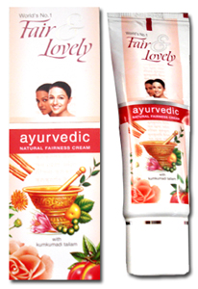 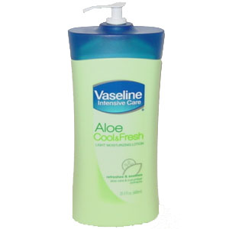

25 gm- Rs.32 300 ml- Rs.95

50 gm- Rs.57

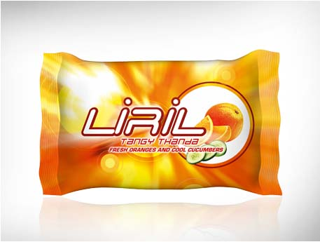 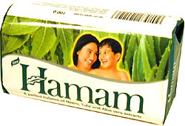

113 gm- Rs.30 135 gm- Rs.25

# Pricing of the Herbal Products:

HUL uses perceived value pricing and penetrates in both rural and urban market at a very affordable price

.

They deliver the value promised, and the customer must perceive this value.

They use the other marketing- mix elements, such as advertising and sales force, to communicate and enhanced perceived value in buyers’ minds.

Perceived value is made up of several elements, such as buyers’ image of the product performance, the channel deliverables, warranty quality, customer support, trustworthiness and esteem.

# Rural Marketing Strategy:

* HUL have maintained a balanced growth between urban and rural. Both markets are growing at the same pace across geographies.
* The strategy of HUL is to target rural consumers separately.
* HUL knows that rural markets have more potential for growth in the future. It is the biggest challenge for them.
* HUL decided to establish strategy of lowering the input cost to arrive at a low cost product for rural consumers.
* They promote their products in rural areas with the help of women.
* They introduced the sachets of fairness cream to make sachets a buying habit of rural consumers.
* They also came up with the soap with a net weight of just 18 gms at a price of Rs.2.
* They initiated “Project Harvest”, “Project Bharat” and “Project Shakti” (which utilized the concept of Self-Help Groups) to extend their distribution to the villages. Each state has their clearing and forwarding agents (C & F) and stockists.
* The company has continuously designed innovative promotions to reach the rural markets. They employed Health Development Officers and Assisstants who went to all villages and educated the community through lectures and community meeting.

# Urban Marketing Strategy:

* HUL have restructured themselves in two divisions:
  1. Food products
  2. Home/Personal products
* They have made changes in the job management structure. They have developed deep level expertise to improve their marketing.
* They are building urban markets as well as their own brands.
* They try to launch their brands in urban areas when innovation pipeline is full.
* They try to deliver substantial performance by looking long term.
* They try to have a clear picture of strategies they develop if they want to win.
* Marketing strategies help them to beat their competitors like CavinKare Ltd., P&G, Marico Group, Dabur, Etc.
* They even conducted marketing workshop at IIM Lucknow on September 26, 2008.
* They use almost all the promotional media to market their skin care products like television, hoarding, websites, etc.
* Wholesalers and retailers are the marketing channels involved in the distribution of skin care products to the end consumer. SHG is also being utilized for the di

# 4-Herbal Products

Skin Care Products Manufactured by Himalaya are-

1. Herbal Products-
2. Face Packs
3. Face Tonners
4. Facial Cleanser
5. Fairness
6. Moisturizers
7. Soaps
8. Face Washes

2- Non Herbal Products-

None

# SOME HERBAL PRODUCTS

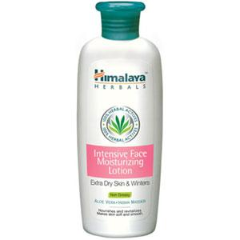 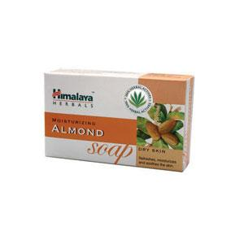

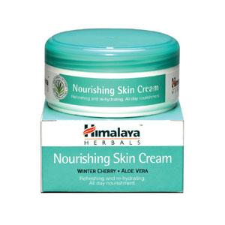

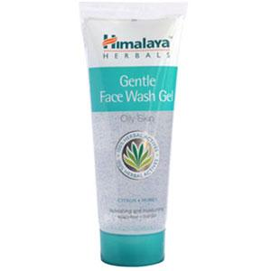

**Pricing of the Herbal Products:**

Himalaya is only known for their unique herbal products. Hence, they also use their brand name for pricing their herbal products. They charge their products at a price which is more as compared to other companies as herbal products are their USP.

Some Prices of Himalaya product-

Himalaya Face Wash Gel- Rs 65

Himalaya skin cream- 100 ml Rs 160

250ml Rs 235

Himalaya intensive face Moisturizing- Rs 155

Himalaya Nourishing Body Lotion- Rs 124

Himalaya Protecting Body Lotion- Rs 125

Himalaya Intensive Moisturizing Body- Rs 140

# Marketing Strategy:

* They target only the urban audience.
* Himalaya tries to grow its personal care products and herbal skin care products lie in this division.
* The company claims that it is one-of-its kind products in the market.
* Himalaya is retailing its personal care products range in multibrand outlets with shop-in-shops.
* Advertising has been focused on the modern urban woman who needs to feel confident and in charge of her life. Outdoor campaigns and television ads of skin acre products are the fast movers. Their skin care products are also being featured in glossy magazines. Himalaya has also promoted its ayurvedic concepts through ‘Dadima’.
* They take care of packaging too for marketing their skin care products. They feel packaging is something that will be viewed by a subset of the audience that the brand is advertised to.
* Isolating Benefits is a strategy which the marketers of Himalaya use for marketing their products. They isolate the benefit of beauty in advertising and the benefit of herbal in packaging.
* They have their own stores known as Himalaya Stores which are being located at 50 different cities/places in India. Some places are Ahmedabad, Agra, Bangalore, Bhopal, Chandigarh, Chennai, Goa, Jaipur, Kolkata, Mumbai, New Delhi, Pune, etc. In Mumbai, their stores are located at Byculla, Colaba, Andheri, Bandra, Navi Mumbai and Matunga.
* They also sell their products through different departmental stores, super markets, etc.

**LATEST DEVELOPMENTS IN SKIN CARE SECTOR**

# Natural Organic Beauty Products Are Essential for Men

Modern men are just as (or at least almost) as concerned with their appearance as women. And healthy skin is a fundamental part of looking great.  
  
For men, skin care is a mere afterthought. Beyond the world of shaving their faces, it is rare for a man to devote time to his skin. These days, skin care is no longer just a woman’s concern. We are in the 21st century, and the pressure is on for man to take care of himself. Men are increasingly aware and concerned about the health of their skin. More men than ever are interested in taking care of their skin, and ensuring that they maintain their youthful looks for as long as possible.  
  
Man’s blooming desire for beautiful skin is an 8 billion dollar industry. So why are men beginning to catch up with women’s interest in beauty products? Most importantly, everyone wants to retain youthful skin for as long as possible. Along with drinking plenty of water and eating a healthy diet, moisturizing and nurturing the skin is the best way to grow old gracefully. Proper skin care is essential to keep this process at bay for as long as possible.  
  
More and more men are reacting to the synthetic chemicals used by many high street brands of male grooming products. Therefore they are turning to natural formulations free from unnecessary synthetic ingredients, which will be absorbed by the body.  
  
Switching to organic food in order to avoid consuming toxins is a popular choice. People are also becoming aware that what is put on the skin will always make its way into the blood stream. That means that if skin care products are full of chemicals, they will eventually be flowing through the body. Since the skin can be a mirror for what is going on in the body, the chemicals may once again show up on the skin. Organic, chemical free moisturizer means no toxins for the body to deal with, and ultimately, healthier skin.

Nearly 80 percent of men say shaving irritates their skin. Razor burn is actually often "product" burn. Many of the products that are designed for men are poorly formulated and contain far too many irritating ingredients.  
  
These skin irritants make the hair follicle and skin swell, forcing the hair up and away from the skin, supposedly allowing for a closer shave. Unfortunately, the irritation and resulting swelling cause some of the hair to be hidden by the swollen follicle and skin. The swollen skin makes it harder for the stubble to find its way back out. If the hair begins to grow (which it does almost immediately) before the swelling is reduced, the likelihood of ingrown hairs is increased.

Shaving with a razor abrades the skin enough to cause havoc, but then men typically splash an aftershave lotion with irritating ingredients over that broken skin. Think of splashing chemicals on a cut or scrape on your body.  
  
Most organic products are mild and won’t irritate the skin, even if there is abrasion.  
  
Other natural products that men are choosing to use are soaps and shower gels. Aluminum and parabens have been linked to cancer and other health complaints, but deodorants free of them are available specially formulated for men.

* **The Best Skin Care Products Are Natural :**

When we say "best skin care products" it means that it is unique and is proven to be effective with striking results. There are a lot of new skin care products nowadays that use a variety of chemicals substances and ingredients which are found to be available in the market.

The products that have been easily adopted by the public are more concentrated with anti-aging which has been developed to diminish the signs of skin aging. This was a breakthrough for skin care technology as an alternative for surgical procedures.

The best skin care products available are in forms of, lotions, serums, moisturizers, creams, gels and masks. All of them may have the same composition in ingredients and a few are distinctive. But whatever these products are made of, there should be always be one concern that should be put into place, these products should never be harmful for the consumers' health and skin.

**For now,** **what consumers can actually rely on is considering natural skin care products as for being the best skin care products available in the market because they are much safer and reliable in terms of the ingredients that are being used.** On the other hand, the best skin care products should be able to address all skin types and whatever climate, in short it should be flexible as possible in addressing all skin issues.

In addressing skin issues, the best skin care products should have the right ingredients and most of the best ingredients available for skin renewal and rejuvenation. You may find natural ingredients that are found to be helpful and provides extensive care to the skin such as avocado extract, shea butter, babassu and natural vitamin E.

Herbal skin care products rarely have any adverse effects on the user and as you can produce them at home, they are very attractive to people trying to avoid anything synthetic.

**CONSUMER SURVEY**

**Total number of consumers surveyed=50**

**Segmentation:**

|  |  |
| --- | --- |
| **Segmentation Variables** | **Data** |
| **Geographic:** |  |
| Country | India |
| City | Mumbai |
| Density | CHEMBUR |
| Climate | Hot, Dry and Humid |
| **Demographic:** |  |
| Age | 15-45 |
| Gender | Female |
| Occupation | Students, Working Women, Housewives |

The following are the preferred types of skin care products:



From the above pie-chart we understand,

* 20% females prefer using creams as their skin care product.
* 24% females prefer using lotions as their skin care product.
* 24% females prefer using soaps as their skin care product.
* 14% females prefer using talcum powder as their skin care product.
* 18% females prefer using all of the above as their skin care product

The following are the preferred Companies for skin care products:



From the above pie-chart we understand,

* 14% females use the skin care product of Cavinkare.
* 16% females use the skin care product of Dabur.
* 28% females use the skin care product of HUL.
* 16% females use the skin care product of Himalaya.
* 26% females use the skin care product of other companies like Johnson & Johnson, Emami, etc.

The following are the places from where the skin care products are bought:



From the above pie-chart we understand,

* 28% females purchase their skin care product from a General Store.
* 18% females purchase their skin care product from a Medical Store.
* 54% females purchase their skin care product from a Super Market or Departmental Store

**The following are the factors which are considered most important while buying the skin acre product**:



From the above pie-chart we understand,

* 26% females consider Brand Name as an important factor while buying the skin care product.
* 12% females consider Price as an important factor while buying the skin care product.
* 52% females consider Quality as an important factor while buying the skin care product.
* 4% females consider Availability as an important factor while buying the skin care product.
* 6% females consider Variety as an important factor while buying the skin care product.

**The following is the frequency of purchasing the skin care product:**



From the above pie-chart we understand,

40% females purchase their skin care product every 1 month.

32% females purchase their skin care product every 2 months.

8% females purchase their skin care product every 3 months.

20% females purchase their skin care product every 4 months.

**The following are the things which influence to buy the skin care product?**



From the above pie-chart we understand,

* 72% females said that their Skin influences them to purchase skin care product.
* 14% females said that Advertisements influence them to purchase skin care product.
* 10% females said that their Family influences them to purchase skin care product.
* 4% females said that their Friends influence them to purchase skin care product.

**The following is the frequency of using the skin care product:**



From the above pie-chart we understand,

* 46% females use their skin care product daily.
* 20% females use their skin care product monthly.
* 34% females use their skin care product as per the seasonal changes.

**The following is what the consumers feel about the price of skin care products:**

**Price of skincare Products**

28%

54%

18%

Cheap

Expensive

Normal

From the above pie-chart we understand,

* 28% females feel that the price of skin acre product is cheap.
* 54% females feel that the price of skin acre product is expensive.
* 18% females feel that the price of skin acre product is normal (i.e. neither cheap nor expensive).

**The following is how frequently the companies’ advertisement is seen by the consumers:**



From the above pie-chart we understand,

* 6% females see advertisements of CavinKare the most.
* 24% females see advertisements of Dabur the most.
* 38% females see advertisements of HUL the most.
* 4% females see advertisements of Himalaya the most.
* 28% females see advertisements of other companies like Johnson & Johnson, Emami, etc. the most.

**The following is how the consumers search information for the skin care product:**



From the above pie-chart we understand,

* 56% females said that they got the information about their skin care product through advertisements.
* 16% females said that they got the information about their skin care product through observation.
* 10% females said that they got the information about their skin care product through personal experience.
* 18% females said that they got the information about their skin care product through relatives.

**COMPARISON BETWEEN HERBAL AND NON-HERBAL SKIN CARE**

**PRODUCTS**

|  |  |
| --- | --- |
| **Herbal skin care products** | **Non-Herbal skin care products** |
| 1. Herbal skin care products are chemical free and contain all kinds of herbs. | Non- Herbal skin care products contain lots of chemicals. |
| 1. Herbal skin care products do not cause any side effects. | Non- Herbal skin care products may cause side effects. |
| 1. Herbal skin care products reaction time is slow as compared to Non- Herbal skin care products. | Non- Herbal skin care products reaction time is fast as compared to Herbal skin care products. |
| 1. Price of Herbal skin care products may be high as compared to Non- Herbal skin care products. | Price of Non-Herbal skin care products may be low as compared to Herbal skin care products. |
| 1. People believe that sooner or later they will get a positive response from using Herbal skin care products. | People do not believe that they will get a positive response from using Non-Herbal skin care products. |

**RECOMMENDATIONS**

1. **Better Services:**

Today, customers are ever more demanding than before. They not only expect good products with excellent quality, but also additional and better services along with them. It is generally found that more than the products; it is the services or the customer-relations that cause the satisfaction or dissatisfaction about what has been offered. Thus, to secure a competitive edge, companies manufacturing skin care products should design and offer their services in a way that create a superior image in the minds of the customer.

1. **Exciting Promotions/ Special Benefits:**

“Value for Money” is the mantra that customers follow irrespective of their income level. Thus, companies manufacturing skin care products should keep introducing promotion schemes that would help increase customer satisfaction and contribute to the ‘loyalty’ aspect.

1. **Introduce Products/ Fragrances with Natural Ingredients:**

People perceive products having natural ingredients as being safer and more effective. As more and more people are shifting towards using natural products, the market for hypoallergenic products is on a steady rise. Further, India is a rich source for natural ingredients, companies manufacturing skin care products should get more into this market and introduce a line of products and fragrances containing only natural ingredients like Himalaya and Dabur does.

1. **Public Relations:**

Companies manufacturing skin care products should indulge in intensive PR activities besides advertising. They could hold PR campaigns like issuing general information press releases on its associated subject, sponsorships or charities to various organizations who are in need, etc.

1. **Electronic newsletter (Ezines):**

Companies manufacturing skin care products should issue monthly magazines containing the latest trends, skin care, etc.

Besides being an effective PR tools, these magazines would also serve as a mean for effective advertising since they could also publish their latest product lines, etc. introduced.

1. **Companies should look at providing services for men:**

Companies manufacturing skin care products should now look at providing services (facials, clean-ups, etc.) for men too. Doing this will increase their customer base.

1. **Start a Telephone Help Line:**

Companies manufacturing skin care products should start a telephone help line in the metros & rural to give assistance regarding skin-care problems and solution. However, they should not look at marketing through this help line, as it dilute the purpose of trying to create favorable relations with the customers. It should not be made necessary to buy a skin care product in order to avail of this free service. This would provide an excellent way of connecting with customers and conversing with them.

**ANNEXURE**

**Questionnaire:**

1. Do you use any skin care product?
   * Yes
   * No
2. Which skin care product do you prefer?

* Herbal
* Non-Herbal
* None of the above

1. Which type of skin care product do you prefer?

* Creams
* Lotions
* Soaps
* Talcum Powder
* All of the above

1. Which Company’s skin care product do you prefer?

* CavinKare
* Dabur
* HUL
* Himalaya
* Johnson and Johnson
* If Others, please specify

1. From where do you buy your skin care product?

* General Store
* Medical Store
* Super Market or Departmental Store

1. According to you, which factor is considered the most important while buying the skin care product?

* Brand Name
* Price
* Quality
* Availability
* Variety

1. How often do you purchase the skincare product?

* 1 month
* 2 month
* 3 month
* 4 month

1. Who or what influences you to purchase the skin care product?

* Your skin
* Ads
* Family
* Friends
* If Others, please specify

1. How frequently do you use the skin care product?

* Daily use
* Monthly
* As per the seasonal changes

1. What do you feel about the price of the skin care products available in the market?

* Cheap
* Expensive
* Normal

1. Which skin care product Company’s advertisement do you see the most?

* CavinKare
* Dabur
* HUL
* Himalaya
* Johnson and Johnson
* If Others, please specify

12) How was the information search done by you for the skin care product you buy?

* Ads
* Observation
* Personal experience
* Friends and Relatives
* If Others, please specify

**CONCLUSION**

The amount of marketing strategies that is taking place in the companies manufacturing skin care products is constantly increasing. Making time for creating good and innovative strategies is often a tough task. Yet the relationship between marketing strategies, companies manufacturing skin care products and profitability is well-documented.

Companies have realized that proper marketing strategies are beneficial, in the long run to both the company as well as the consumers using the skin care products.

Business competition compels companies manufacturing skin care products to attract, retain and develop marketing strategies for enhancing their competitive edge. This is also a necessity for retaining loyal consumers.

With new trends and improvement in techniques of developing marketing strategies will enhance the growth of the companies manufacturing skin care products.

Thus, the role of marketing strategies in the companies manufacturing skin care products is getting more vital by each passing day.

# BIBLIOGRAPHY

1- <http://en.wikipedia.org/wiki/Human_skin>

2-<http://www.cancer.org.au/preventing-cancer/sun-protection/preventing-skin-cancer/>\

3-<http://store.himalayahealthcare.com/quickorder.asp?source=adwords&gclid=CNjv-c2ooLoCFW964godYxUAjw>

4-<http://www.dabur.com/default.aspx>

5-<http://www.cavinkare.com/>

6-<http://www.hul.co.in/>

7- <http://www.vedicline.com/alpha-whitening-skin-care.html>